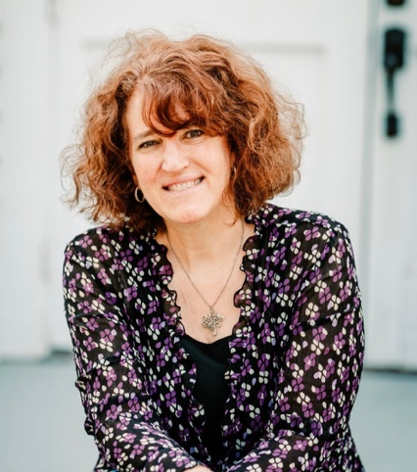

<https://freshexpressions.com/prayer-ministry>

As a global spiritual coach, Cheryl diligently intercedes in prayer on behalf of Fresh Expressions' pioneering mission and leadership multiplication initiatives. Since being Director of The Chapel (known initially as The Ananias Project) and Coordinator of Prayer Mobilization for Fresh Expressions NA since 2014, Cheryl has been instrumental as a prophetic voice and guide to the missional movement.

Offering Transforming Prayer Sessions through The Center for ReMissioning, she employs over 30 years of prophetic and intercessory prayer experience to support pastors and pioneers throughout North America and globally. Alongside her husband, Bill, they have ministered in multiple church plants for over three decades through prayer and worship ministry that began at Truro Anglican Church in Fairfax, VA, in 1991.

Cheryl co-founded and served as Executive Director of The SEEDS Ministry in New Bern, NC, for six years, driving Kingdom Transformation across denominational lines through Prayer, Connection, and Empowerment, thus fostering a community ignited by the Holy Spirit.

Leading Prayer Retreats and facilitating Encounter Prayer Rooms, known as Chapels, for National Gatherings, Cheryl and Bill exemplify spiritual leadership. They continue their journey from their home in New Bern, NC. They are almost empty nesters raising five beautiful children.